**学生信息管理系统**

**学号：202299009772 姓名：李俊杰 班级：22本计算机国际ZY1班**

**一、项目功能介绍**

**项目概述**

本系统是一个基于 JSP 和 MySQL 的学生信息管理系统，提供了一整套的学生信息和课程管理功能。通过易用的用户界面和良好的交互设计，用户可以轻松完成学生信息和课程的增删改查操作，适用于教学管理场景。

**1.1 用户登录与注册**

（1）功能概述：

1. 登录功能

提供用户身份验证，确保系统的安全性。用户通过输入用户名和密码进行登录，未注册用户无法访问系统

2. 注册功能

允许新用户注册，注册过程中会验证用户名的唯一性

**1.2 学生信息管理**

1. 显示学生信息

以分页表格的形式展示所有学生的详细信息，包括学号、姓名、性别、地址、系别、电话和邮箱。

2. 查询功能

用户可以根据学号、姓名、性别和系别筛选学生信息，支持模糊查询。

3. 添加学生信息

通过填写表单新增学生记录，并验证数据的完整性和正确性。

4. 修改学生信息

允许用户更新学生的个人信息（如姓名、性别、地址等）。

5. 删除学生信息

支持单条记录的删除操作，删除前提供确认提示，确保数据安全。

**1.3 课程管理**

1. 显示课程信息

以表格形式展示课程表，包括时间段和每周的课程安排。

2. 修改课程信息

支持单天课程的编辑，用户可以通过输入框修改从早到晚的所有课程内容。

3. 课程数据的完整性

确保修改操作仅影响当天的数据，不会破坏其他时间段的安排。

**1.4 系统结构**

1. 数据库设计

• 用户表：存储用户的注册信息。

• 学生信息表：包含学生的详细信息。

• 课程表：记录每周的课程安排。

2. 页面交互

系统采用了分层设计，每个功能模块都有独立的 JSP 页面，通过表单和链接完成用户交互。

3. 样式设计

使用统一的 CSS 样式，提供简洁、直观的用户界面。

**二、项目结构截图**

**2.1 页面截图**

**1.登入界面**

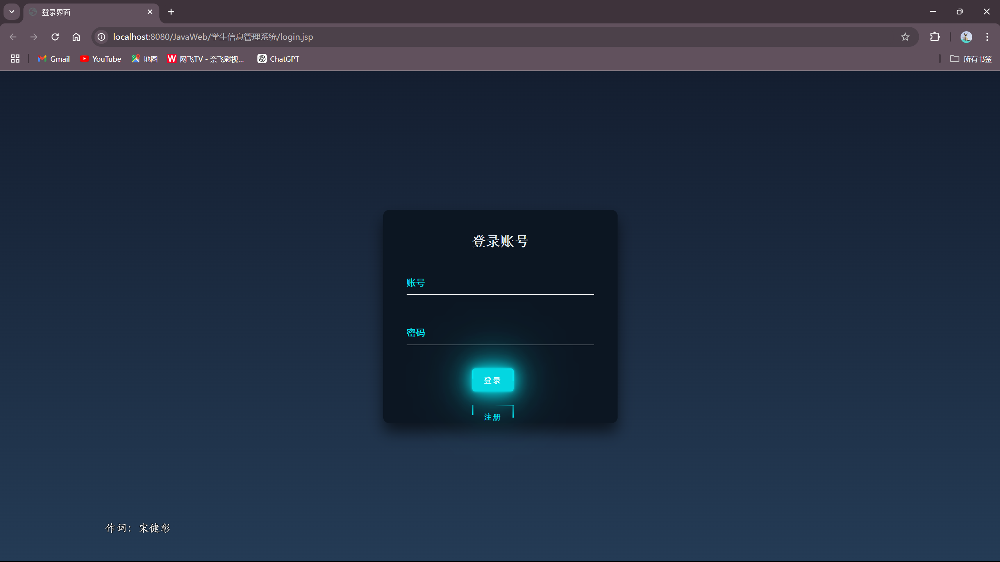

**2.注册界面**

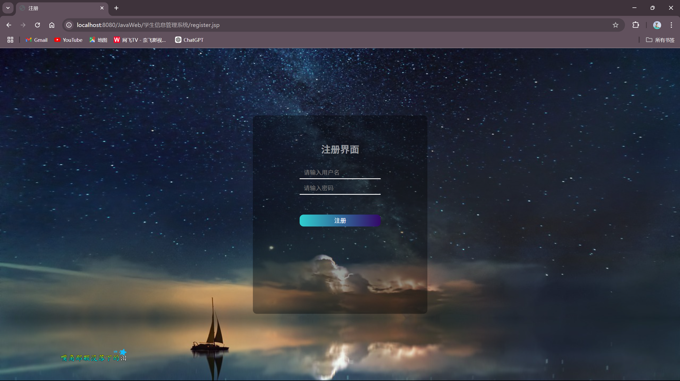

**3.学生信息表界面**

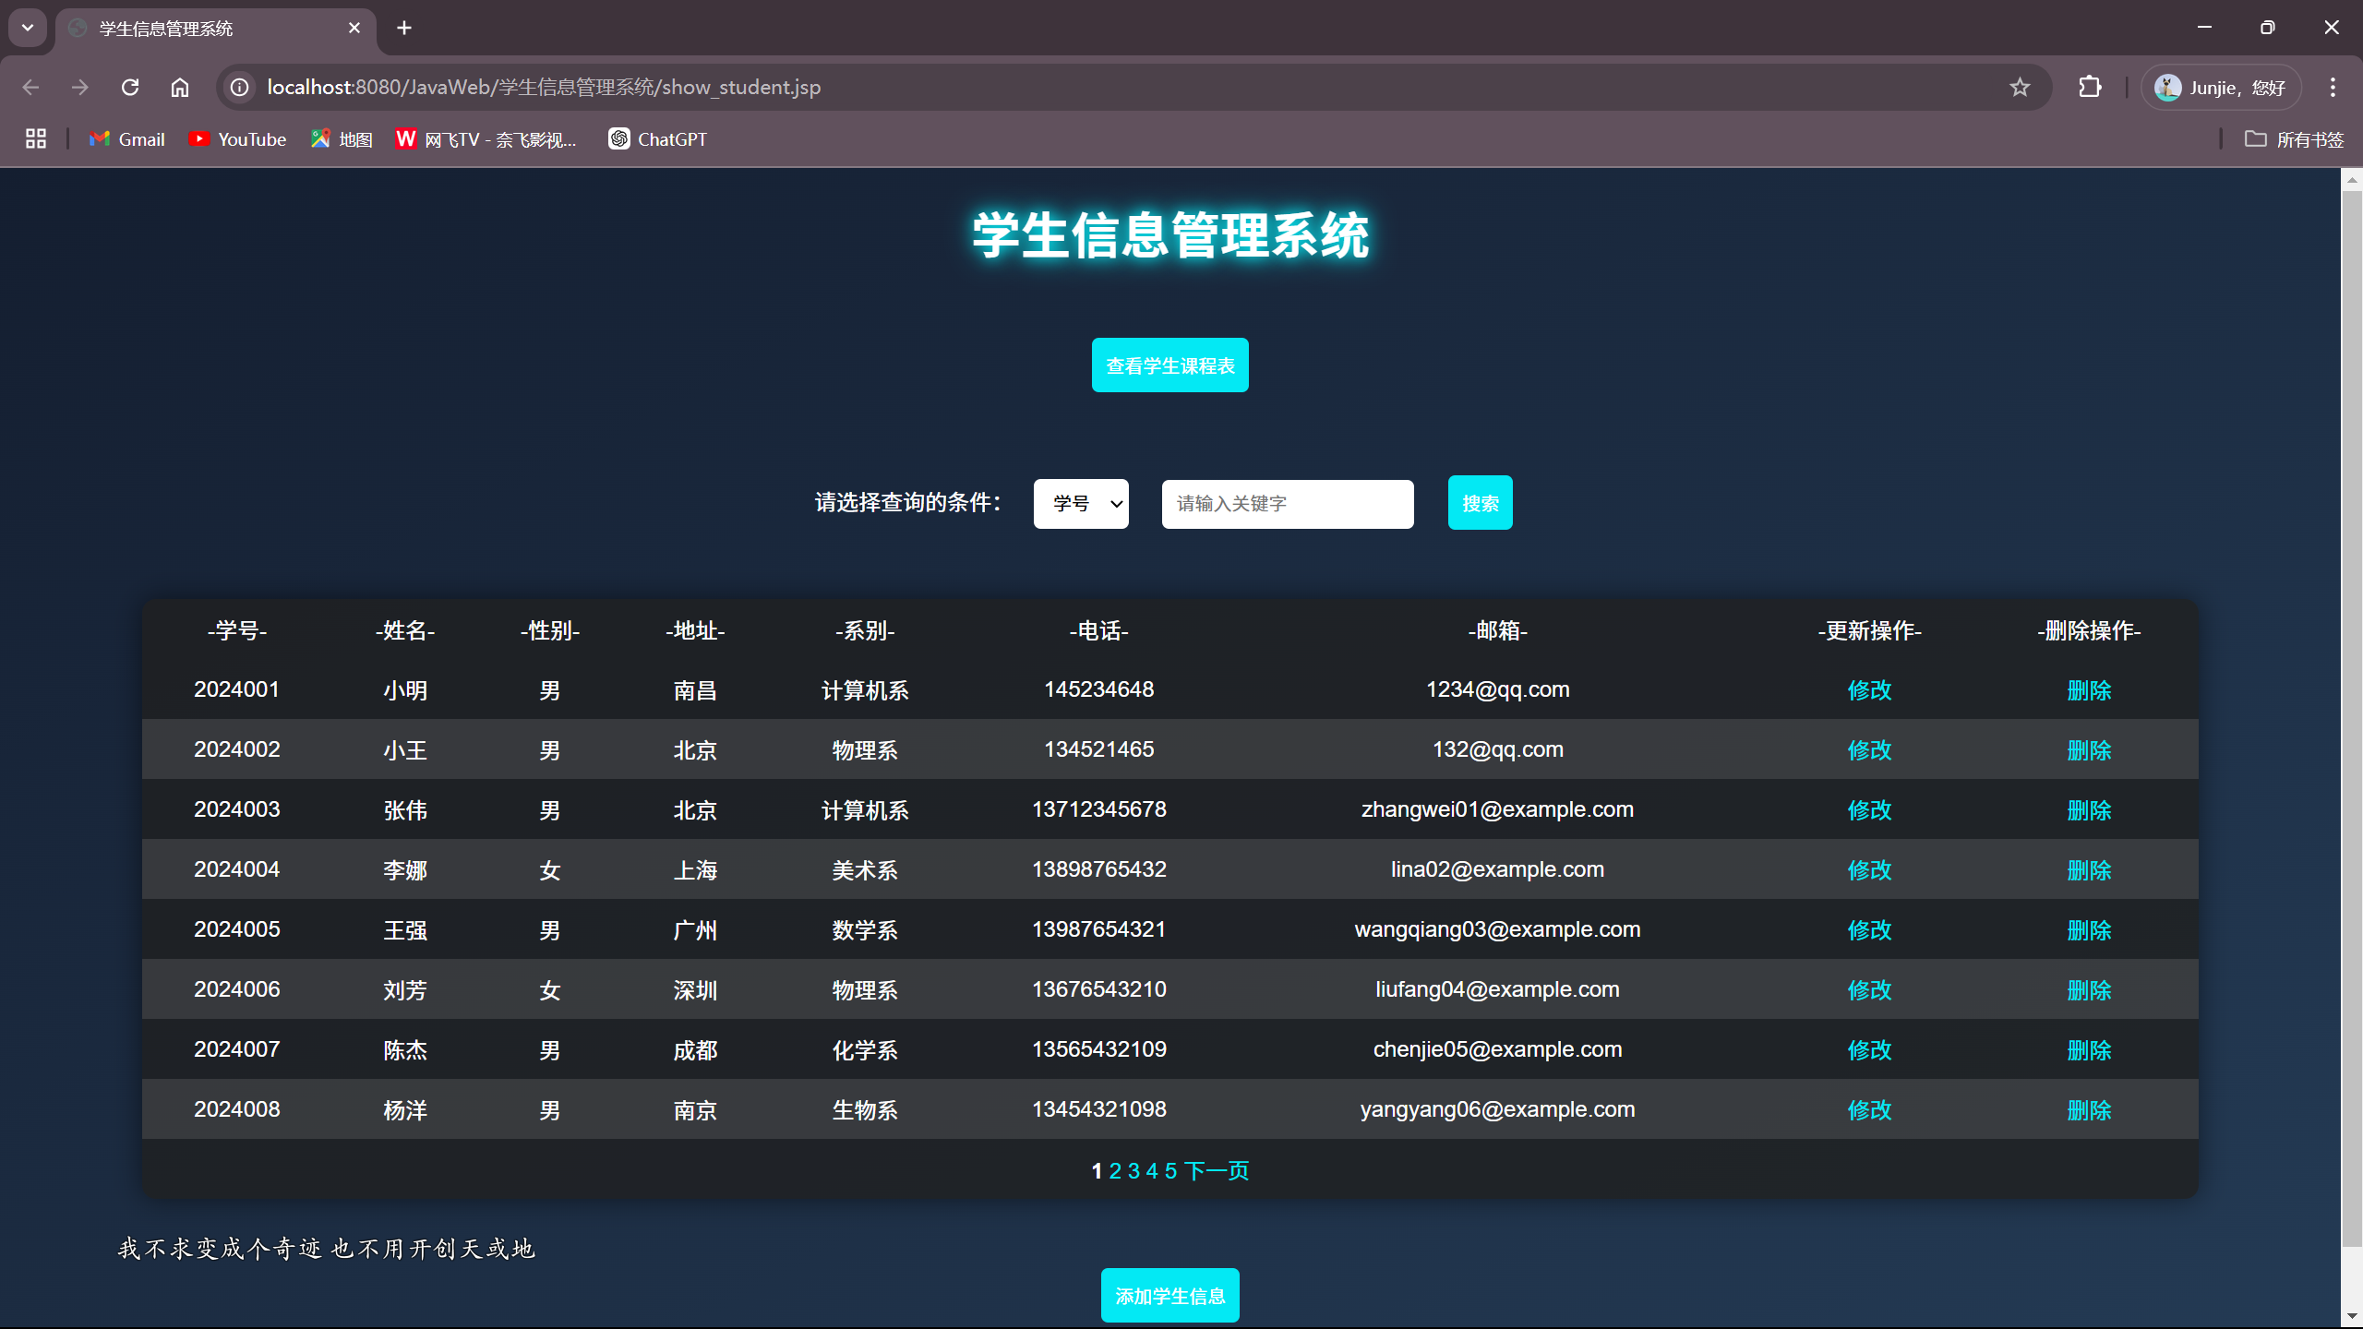

**4.搜索学生信息界面**

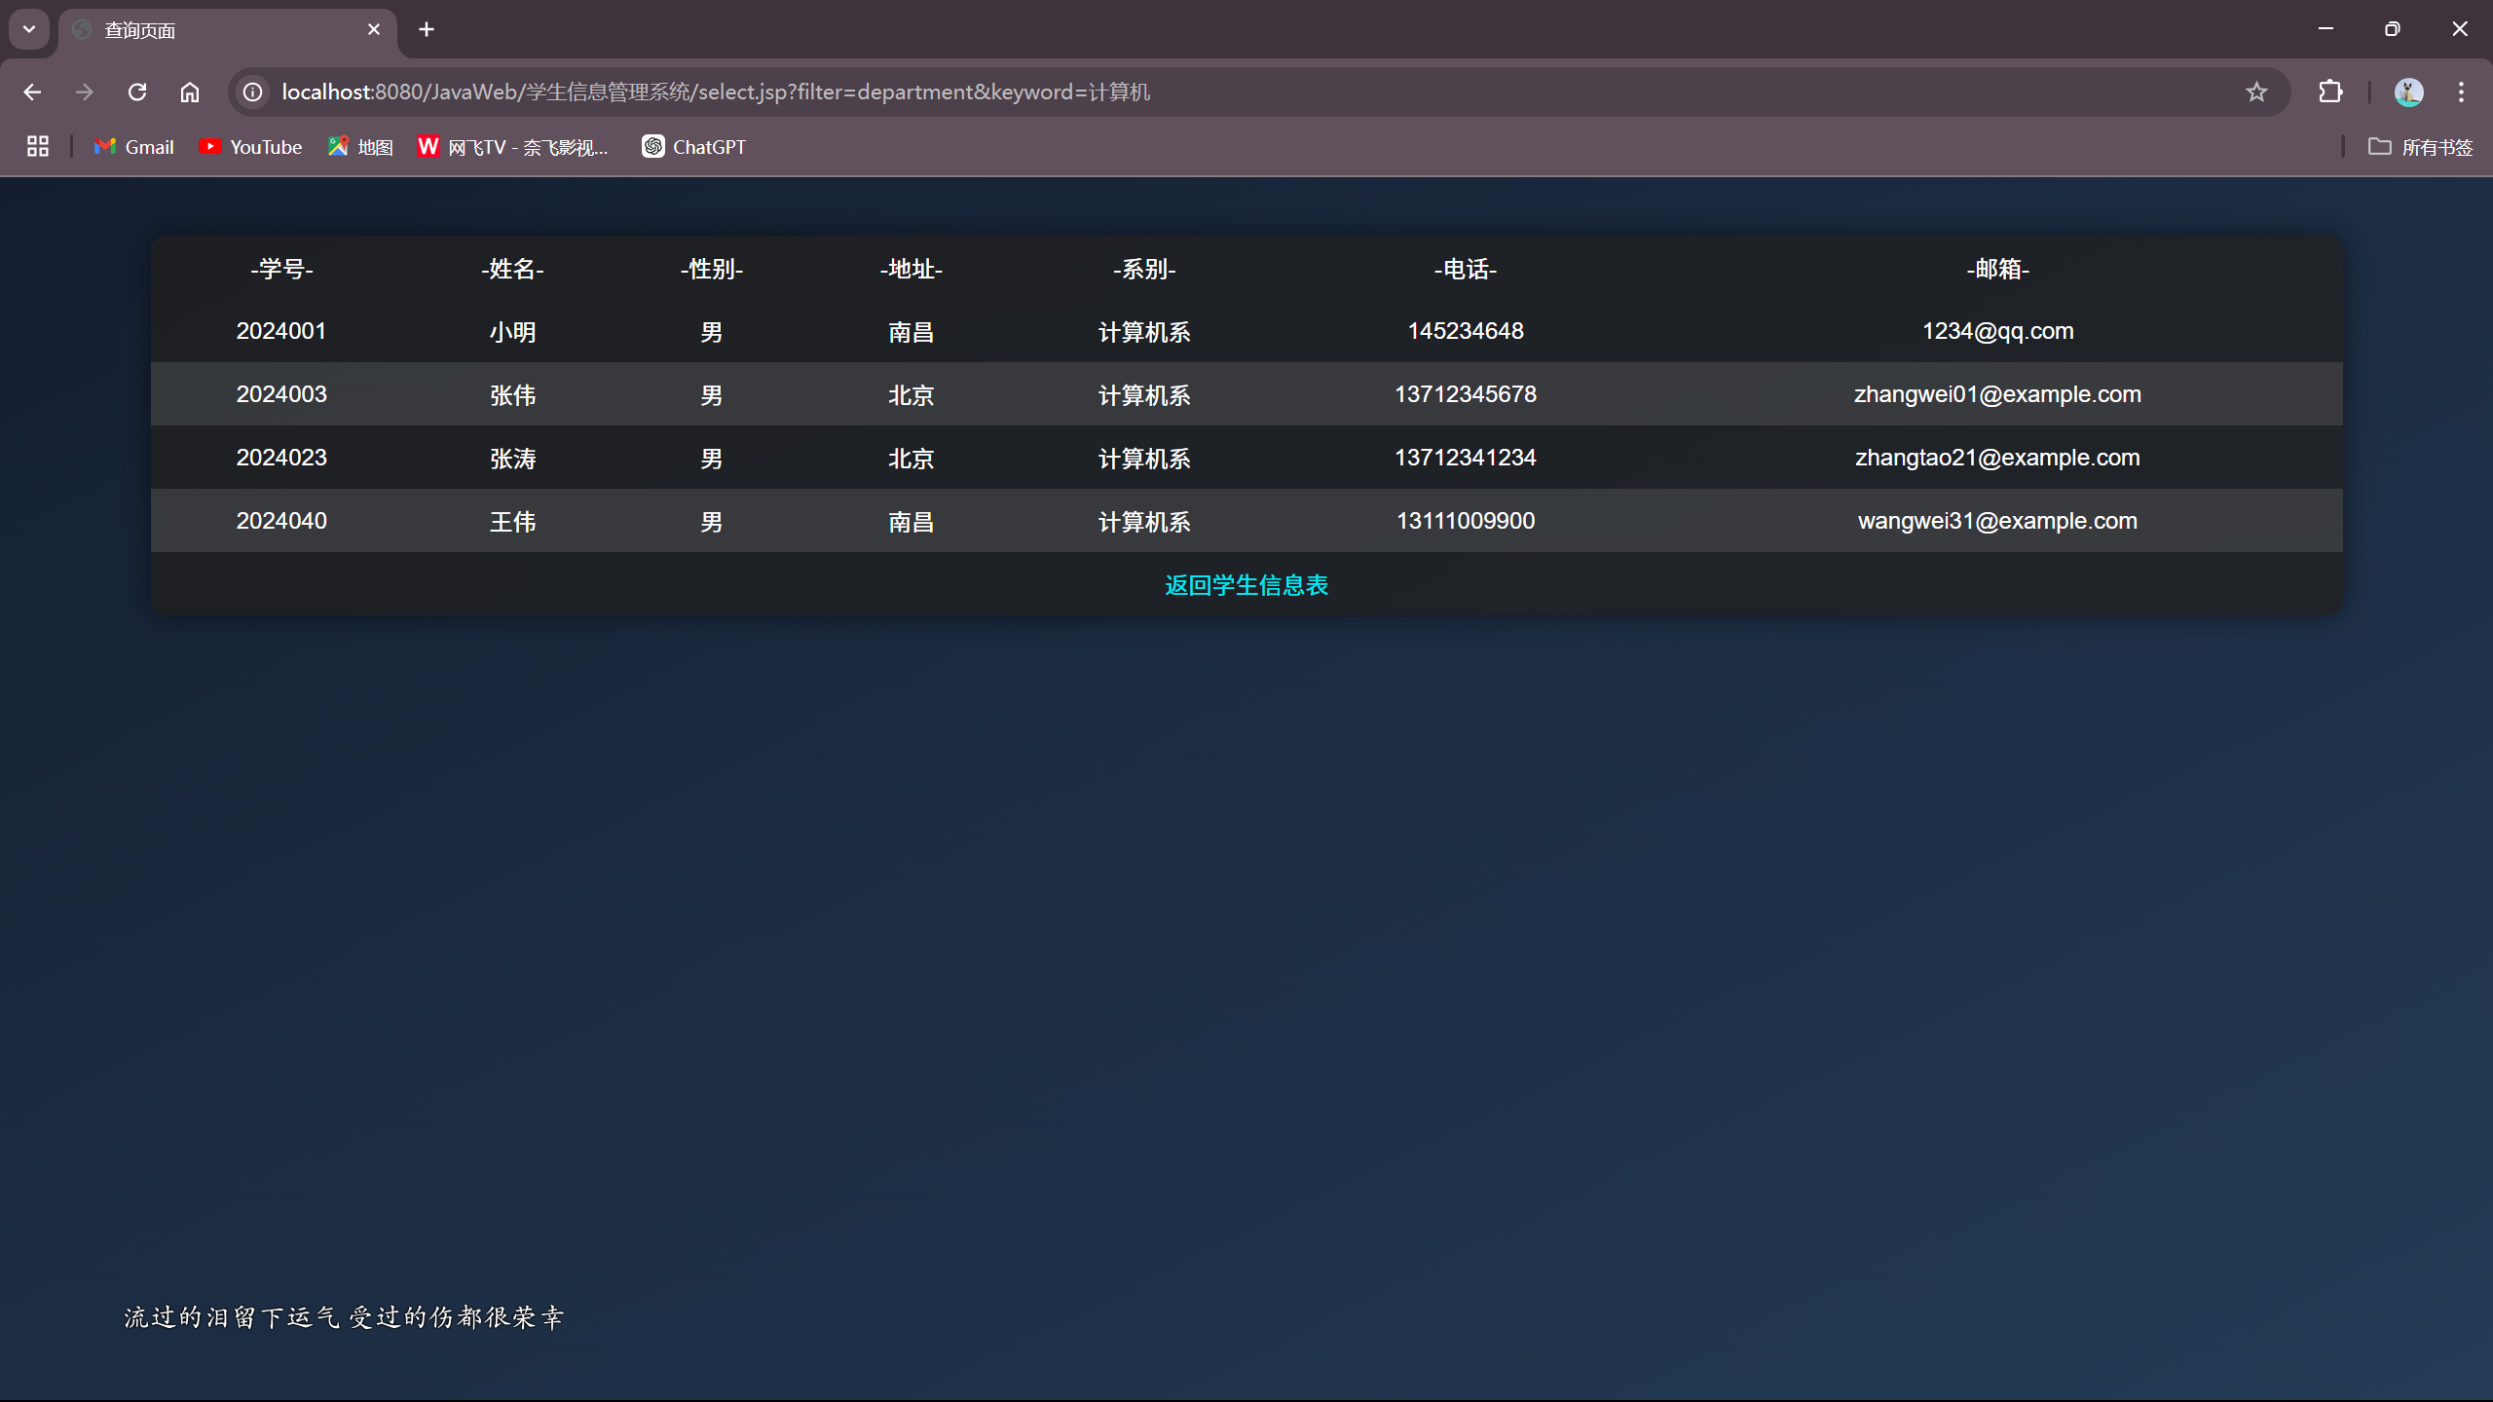

**5.添加学生信息界面**

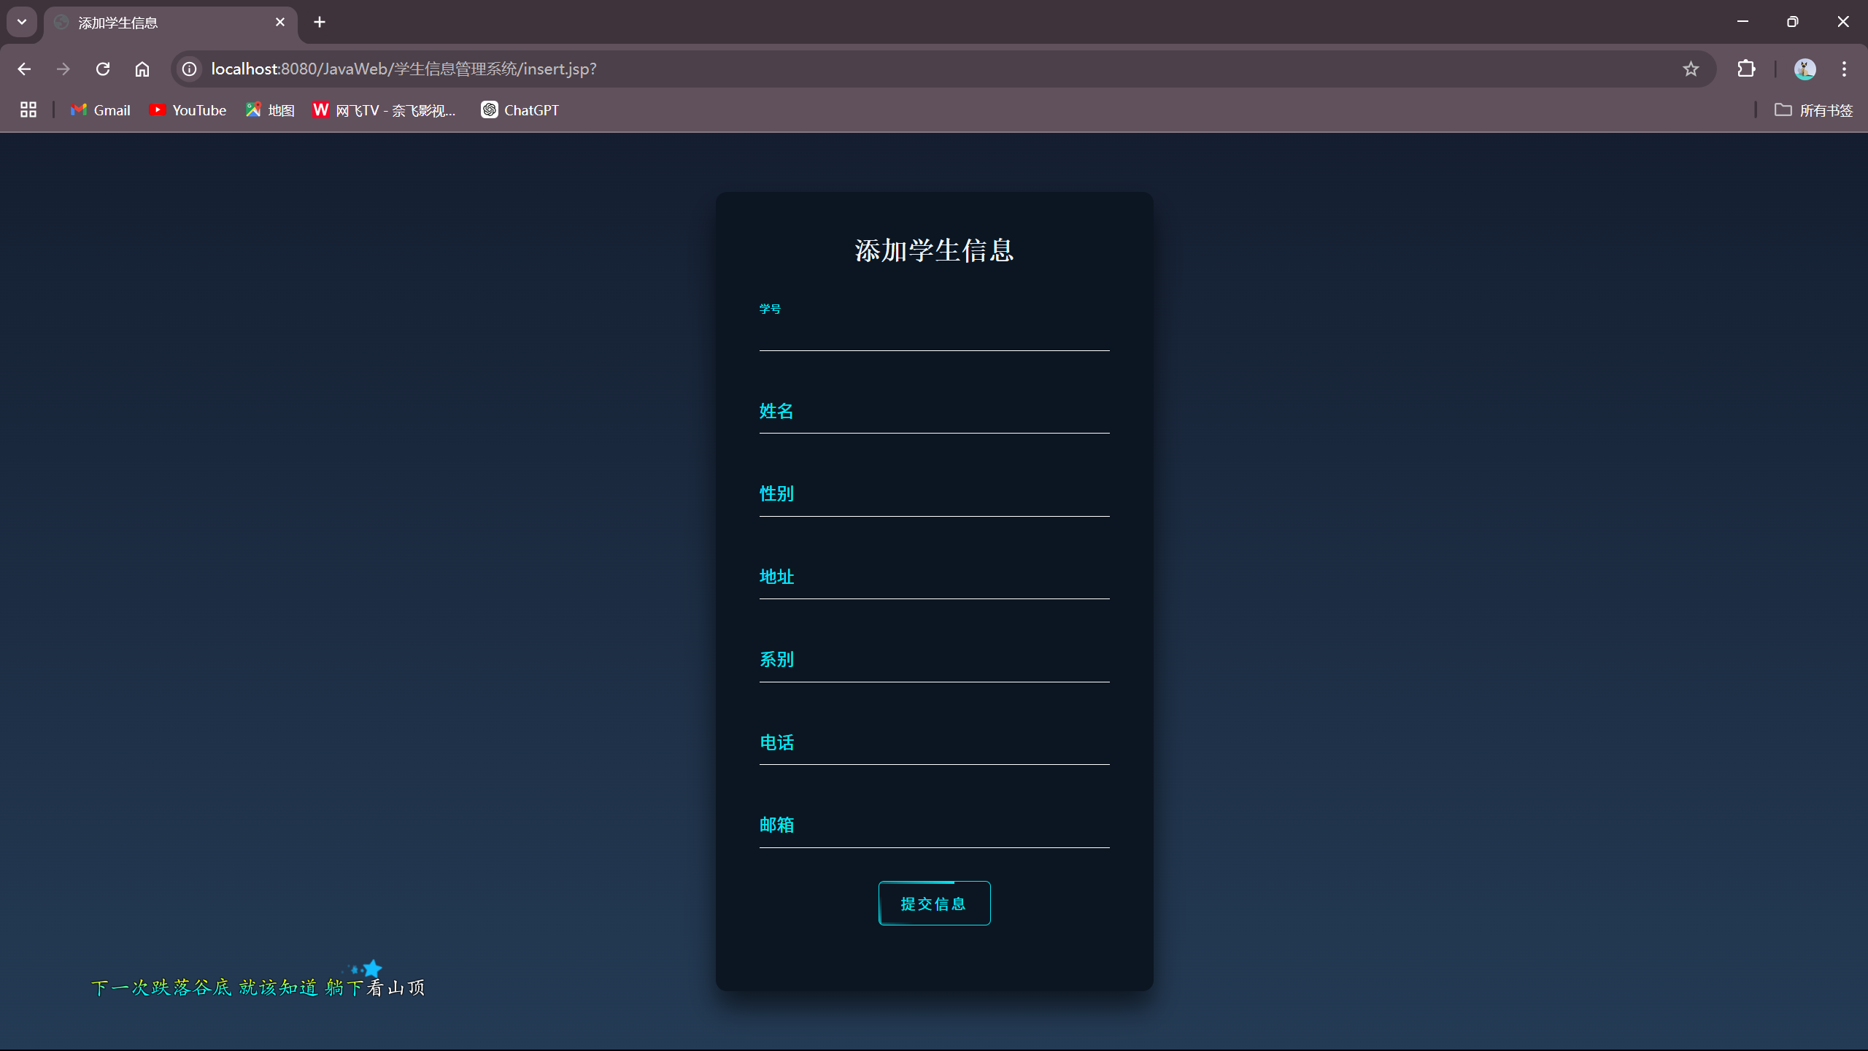

**6.修改学生信息界面**

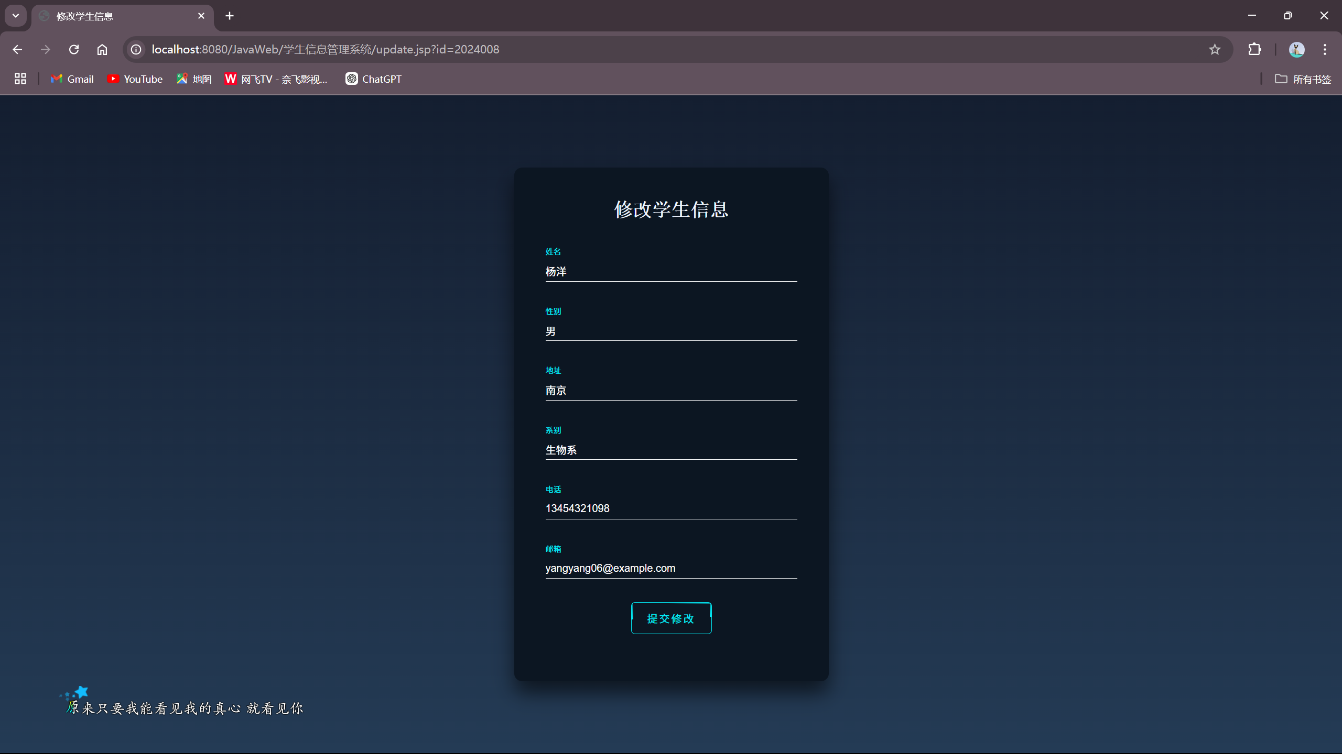

**7.数据库设计**

**（1）user表**

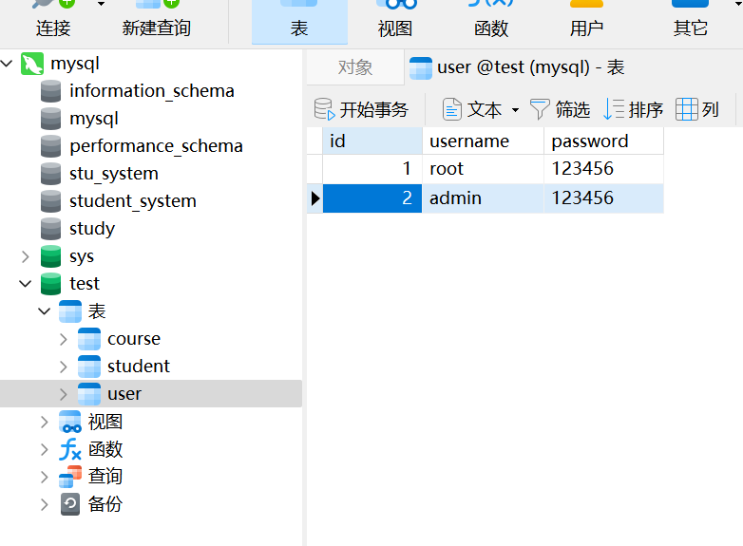

**（2）student表**

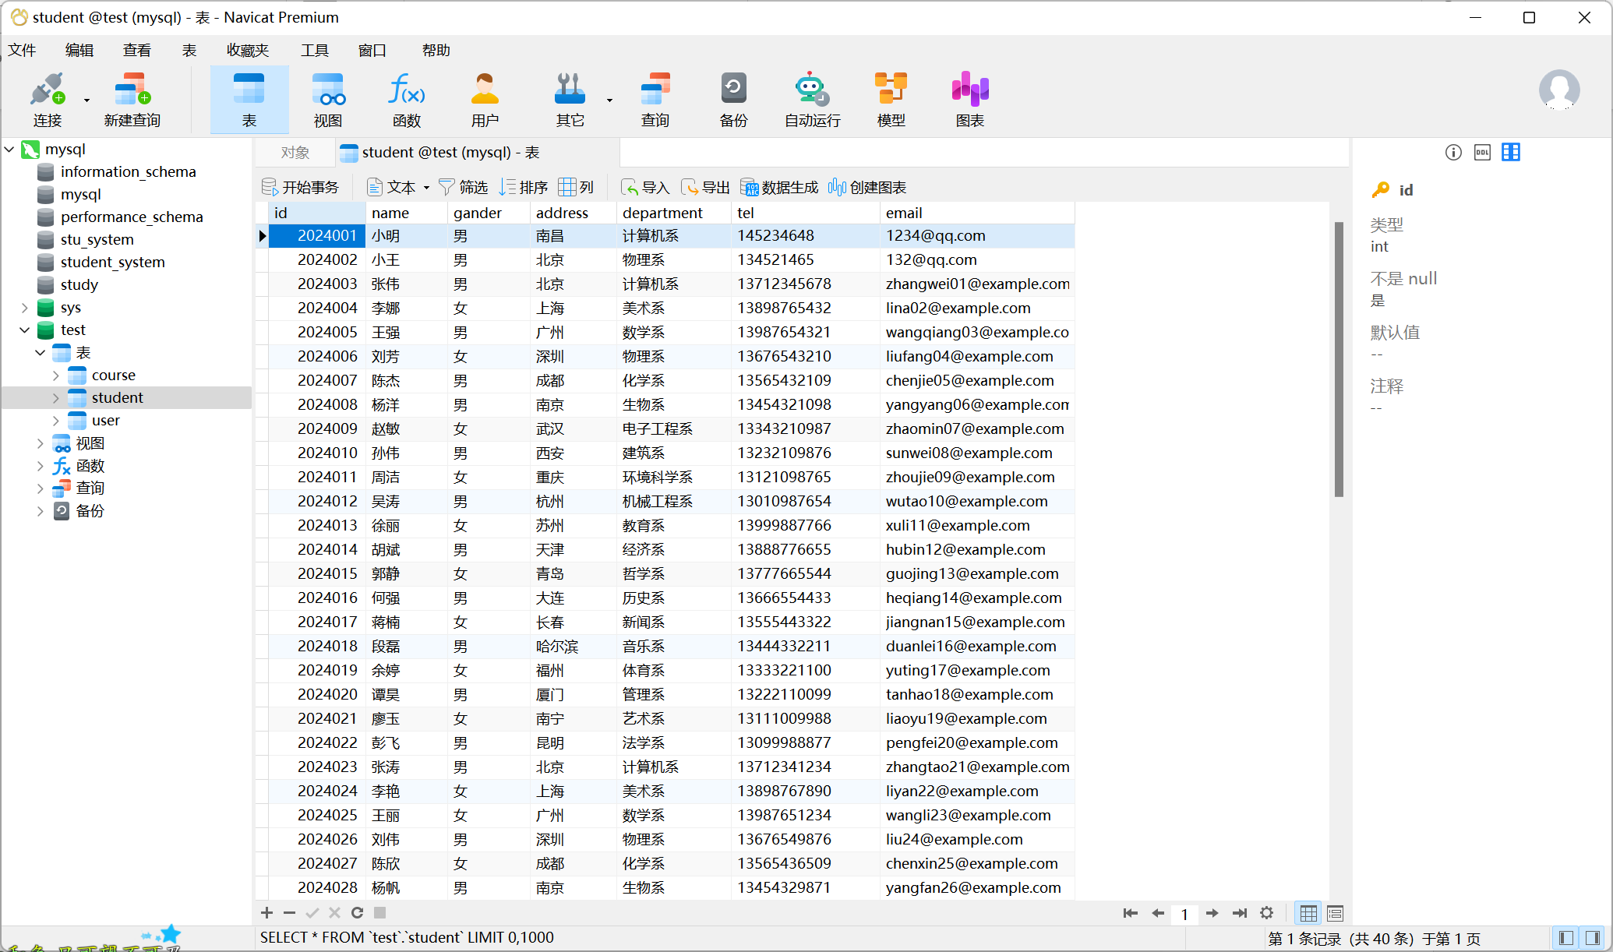

**（3）course表**

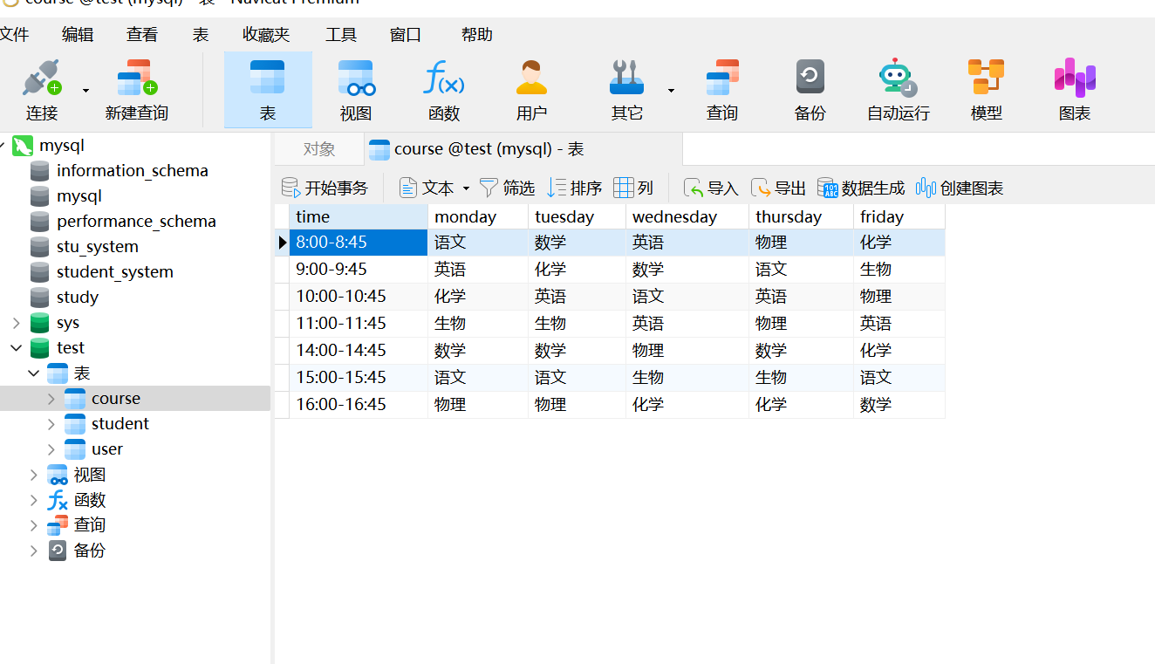

**2.2 后端代码**

**1.login.jsp**

*<%--  
 Created by IntelliJ IDEA.  
 User: ljj  
 Date: 2024/12/9  
 Time: 15:10  
 To change this template use File | Settings | File Templates.  
--%>*<%@ page contentType="text/html;charset=UTF-8" language="java" %>  
<html>  
<head>  
 <title>登录界面</title>  
</head>  
<link rel="stylesheet" href="./css/login.css">  
<body>  
<div class="loginBox">  
 <form action="login_check.jsp" method="post">  
 <h2>登录账号</h2>  
 <div class="item">  
 <input type="text" name="uname" id="uname" required>  
 <label>账号</label>  
 </div>  
 <div class="item">  
 <input type="password" name="upwd" id="upwd" required>  
 <label>密码</label>  
 </div>  
 <button class="btn" type="submit">登录  
 <span></span>  
 <span></span>  
 <span></span>  
 <span></span>  
 </button>  
 </form>  
 <br>  
 <form action="register.jsp" method="post">  
 <button class="btn" type="submit">注册  
 <span></span>  
 <span></span>  
 <span></span>  
 <span></span>  
 </button>  
 </form>  
</div>  
</body>  
</html>

**2.login_check.jsp**

<%@ page import="com.bean.DatabaseConnection" %>  
<%@ page import="java.sql.ResultSet" %>  
<%@ page import="java.sql.SQLException" %>  
*<%--  
 Created by IntelliJ IDEA.  
 User: ljj  
 Date: 2024/12/9  
 Time: 15:31  
 To change this template use File | Settings | File Templates.  
--%>*<%@ page language="java" contentType="text/html; charset=UTF-8" pageEncoding="UTF-8" %>  
<!DOCTYPE html>  
<html lang="en">  
<head>  
 <meta charset="UTF-8">  
 <meta name="viewport" content="width=device-width, initial-scale=1.0">  
 <title>登录验证</title>  
 <style>  
 * {  
 margin: 0;  
 padding: 0;  
 box-sizing: border-box;  
 }  
  
 body {  
 height: 100vh;  
 background: linear-gradient(to bottom right, #141e30, #243b55);  
 display: flex;  
 justify-content: center;  
 align-items: center;  
 font-family: 'Arial', sans-serif;  
 color: #fff;  
 }  
  
 .container {  
 width: 400px;  
 background-color: rgba(0, 0, 0, 0.8);  
 padding: 20px;  
 border-radius: 10px;  
 text-align: center;  
 box-shadow: 0 0 20px rgba(0, 0, 0, 0.5);  
 }  
  
 h2 {  
 font-size: 24px;  
 margin-bottom: 20px;  
 }  
  
 .links a {  
 display: block;  
 margin: 10px 0;  
 text-decoration: none;  
 color: #03e9f4;  
 font-size: 18px;  
 transition: color 0.3s;  
 }  
  
 .links a:hover {  
 color: #fff;  
 text-shadow: 0 0 5px #03e9f4, 0 0 10px #03e9f4, 0 0 20px #03e9f4;  
 }  
  
 .button {  
 padding: 10px 20px;  
 margin-top: 20px;  
 color: #03e9f4;  
 background: none;  
 border: 1px solid #03e9f4;  
 cursor: pointer;  
 transition: 0.5s;  
 text-transform: uppercase;  
 letter-spacing: 2px;  
 }  
  
 .button:hover {  
 background: #03e9f4;  
 color: #000;  
 box-shadow: 0 0 10px #03e9f4, 0 0 20px #03e9f4, 0 0 40px #03e9f4;  
 }  
 </style>  
</head>  
<body>  
<div class="container">  
 <%  
 String username = request.getParameter("uname");  
 String password = request.getParameter("upwd");  
 DatabaseConnection DC = new DatabaseConnection();  
 String sql = "select * from user where username = ? and password = ?";  
 ResultSet rs = null;  
 try {  
 rs = DC.doPreparedQuery(sql, username, password);  
 if (rs.next()) {  
 %>  
 <h2>登录成功，欢迎您！<%= username %>  
 </h2>  
 <div class="links">  
 <a href="show_student.jsp">学生信息表查看</a>  
 <a href="show_course.jsp">课程表查看</a>  
 </div>  
 <%  
 } else {  
 %>  
 <h2>登录失败，请重试。</h2>  
 <a href="login.jsp" class="button">返回登录</a>  
 <%  
 }  
 } catch (Exception e) {  
 e.printStackTrace();  
 } finally {  
 try {  
 DC.close();  
 } catch (SQLException e) {  
 e.printStackTrace();  
 }  
 }  
 %>  
</div>  
</body>  
</html>

**3.register.jsp**

*<%--  
 Created by IntelliJ IDEA.  
 User: ljj  
 Date: 2024/12/9  
 Time: 15:29  
 To change this template use File | Settings | File Templates.  
--%>*<%@ page import="com.bean.DatabaseConnection" %>  
<%@ page import="java.sql.Connection" %>  
<%@ page import="java.sql.PreparedStatement" %>  
<%@ page import="java.sql.ResultSet" %>  
<%@ page contentType="text/html;charset=UTF-8" language="java" %>  
<html>  
<head>  
 <title>注册</title>  
</head>  
<link rel="stylesheet" href="./css/register.css">  
<body>  
<div id="login_box">  
 <h2>注册界面</h2>  
 <form action="register.jsp" method="post">  
 <div id="input_box">  
 <input type="text" placeholder="请输入用户名" name="uname" id="uname" required>  
 </div>  
 <div class="input_box">  
 <input type="password" placeholder="请输入密码" name="upwd" id="upwd" required>  
 </div>  
 <button type="submit">注册</button>  
 <br>  
 </form>  
</div>  
  
<%  
 *// 判断是否有表单提交* String uname = request.getParameter("uname");  
 String upwd = request.getParameter("upwd");  
  
 if (uname != null && upwd != null) {  
 try {  
 Connection conn = DatabaseConnection.*getConnection*();  
  
 String checkUserSql = "SELECT COUNT(*) FROM user WHERE username = ?";  
 PreparedStatement checkStmt = conn.prepareStatement(checkUserSql);  
 checkStmt.setString(1, uname);  
 ResultSet rs = checkStmt.executeQuery();  
  
 if (rs.next() && rs.getInt(1) > 0) {  
 out.println("<script>alert('用户名已存在，请重新注册！'); window.location.href='register.jsp';</script>");  
 } else {  
 String insertUserSql = "INSERT INTO user (username, password) VALUES (?, ?)";  
 PreparedStatement insertStmt = conn.prepareStatement(insertUserSql);  
 insertStmt.setString(1, uname);  
 insertStmt.setString(2, upwd);  
 insertStmt.executeUpdate();  
  
 out.println("<script>alert('注册成功，请登录！'); window.location.href='login.jsp';</script>");  
 }  
  
 rs.close();  
 checkStmt.close();  
 conn.close();  
 } catch (Exception e) {  
 e.printStackTrace();  
 }  
 }  
%>  
</body>  
</html>

**4.show_student.jsp**

*<%--  
 Created by IntelliJ IDEA.  
 User: ljj  
 Date: 2024/12/9  
 Time: 20:38  
 To change this template use File | Settings | File Templates.  
--%>*<%@ page import="java.util.List" %>  
<%@ page import="java.util.ArrayList" %>  
<%@ page import="com.bean.DatabaseConnection" %>  
<%@ page import="java.sql.*" %>  
<%@ page contentType="text/html;charset=UTF-8" language="java" %>  
<html>  
<head>  
 <title>学生信息管理系统</title>  
</head>  
<link rel="stylesheet" href="./css/table_show.css">  
<body>  
<h1>  
 学生信息管理系统  
</h1>  
*<%--跳转到学生课程表--%>*<div class="form-container">  
 <form action="show_course.jsp">  
 <input type="submit" value="查看学生课程表">  
 </form>  
</div>  
*<%--查询--%>*<div class="form-container">  
 <form action="select.jsp" method="get">  
 <label>  
 请选择查询的条件：  
 <select name="filter">  
 <option value="id">学号</option>  
 <option value="name">姓名</option>  
 <option value="department">系别</option>  
 <option value="gander">性别</option>  
 </select>  
 </label>  
 <input type="text" name="keyword" placeholder="请输入关键字" required>  
 <input type="submit" value="搜索">  
 </form>  
</div>  
  
  
*<%--分页查询参数--%>*<%  
 int pageSize = 8;  
 int currentPage = 1;  
 if (request.getParameter("page") != null) {  
 currentPage = Integer.*parseInt*(request.getParameter("page"));  
 }  
 int offset = (currentPage - 1) * pageSize;  
 int totalRecords = 0;  
 int totalPages = 0;  
  
 List<String[]> studentList = new ArrayList<>();  
  
 try {  
 Connection conn = DatabaseConnection.*getConnection*();  
  
 *// 获取总记录数* String countSql = "SELECT COUNT(*) FROM student";  
 PreparedStatement countStmt = conn.prepareStatement(countSql);  
 ResultSet countRs = countStmt.executeQuery();  
 if (countRs.next()) {  
 totalRecords = countRs.getInt(1);  
 }  
 totalPages = (int) Math.*ceil*((double) totalRecords / pageSize);  
  
 *// 分页查询* String querySql = "SELECT * FROM student LIMIT ?, ?";  
 PreparedStatement queryStmt = conn.prepareStatement(querySql);  
 queryStmt.setInt(1, offset);  
 queryStmt.setInt(2, pageSize);  
 ResultSet rs = queryStmt.executeQuery();  
  
 while (rs.next()) {  
 String[] student = new String[7];  
 student[0] = String.*valueOf*(rs.getInt("id"));  
 student[1] = rs.getString("name");  
 student[2] = rs.getString("gander");  
 student[3] = rs.getString("address");  
 student[4] = rs.getString("department");  
 student[5] = rs.getString("tel");  
 student[6] = rs.getString("email");  
 studentList.add(student);  
 }  
  
 rs.close();  
 queryStmt.close();  
 countStmt.close();  
 conn.close();  
 } catch (Exception e) {  
 e.printStackTrace();  
 }  
%>  
  
<table>  
 <thead>  
 <tr>  
 <td>-学号-</td>  
 <td>-姓名-</td>  
 <td>-性别-</td>  
 <td>-地址-</td>  
 <td>-系别-</td>  
 <td>-电话-</td>  
 <td>-邮箱-</td>  
 <td>-更新操作-</td>  
 <td>-删除操作-</td>  
 </tr>  
 </thead>  
  
 <% for (String[] student : studentList) { %>  
 <tr>  
 <td><%= student[0] %>  
 </td>  
 <td><%= student[1] %>  
 </td>  
 <td><%= student[2] %>  
 </td>  
 <td><%= student[3] %>  
 </td>  
 <td><%= student[4] %>  
 </td>  
 <td><%= student[5] %>  
 </td>  
 <td><%= student[6] %>  
 </td>  
 <td><a href="edit_student.jsp?id=<%= student[0] %>">修改</a></td>  
 <td>  
 <a href="show_student.jsp?id=<%= student[0] %>"  
 onclick="return *confirm*('确定要删除这条记录吗？');">删除</a>  
 </td>  
 </tr>  
 <% } %>  
 *<%--分页导航--%>* <tfoot>  
 <tr>  
 <td colspan="9">  
 <% if (currentPage > 1) { %>  
 <a href="?page=<%= currentPage - 1 %>">上一页</a>  
 <% } %>  
 <% for (int i = 1; i <= totalPages; i++) { %>  
 <% if (i == currentPage) { %>  
 <b><%= i %>  
 </b>  
 <% } else { %>  
 <a href="?page=<%= i %>"><%= i %>  
 </a>  
 <% } %>  
 <% } %>  
 <% if (currentPage < totalPages) { %>  
 <a href="?page=<%= currentPage + 1 %>">下一页</a>  
 <% } %>  
 </td>  
 </tr>  
 </tfoot>  
</table>  
*<%--添加--%>*<div class="form-container">  
 <form action="add_student.jsp">  
 <input type="submit" value="添加学生信息">  
 </form>  
</div>  
  
<%  
 *// 检查是否有删除操作* String idParam = request.getParameter("id");  
 if (idParam != null && !idParam.isEmpty()) {  
 try {  
 int id = Integer.*parseInt*(idParam);  
  
 try (Connection conn = DatabaseConnection.*getConnection*()) {  
 String sql = "DELETE FROM student WHERE id = ?";  
 PreparedStatement ps = conn.prepareStatement(sql);  
 ps.setInt(1, id);  
  
 int rows = ps.executeUpdate();  
 if (rows > 0) {  
 out.print("<script>alert('删除成功！'); window.location.href='show_student.jsp';</script>");  
 } else {  
 out.print("<script>alert('删除失败！没有找到该记录。'); window.location.href='show_student.jsp';</script>");  
 }  
 ps.close();  
 }  
 } catch (NumberFormatException e) {  
 out.print("<script>alert('ID格式错误！'); window.location.href='show_student.jsp';</script>");  
 } catch (Exception e) {  
 out.print("<script>alert('发生错误：" + e.getMessage() + "'); window.location.href='show_student.jsp';</script>");  
 }  
 }  
%>  
</body>  
</html>

**5.show_course.jsp**

*<%--  
 Created by IntelliJ IDEA.  
 User: ljj  
 Date: 2024/12/11  
 Time: 17:11  
 To change this template use File | Settings | File Templates.  
--%>*<%@ page import="java.util.List" %>  
<%@ page import="java.util.ArrayList" %>  
<%@ page import="com.bean.DatabaseConnection" %>  
<%@ page import="java.sql.*" %>  
<%@ page contentType="text/html;charset=UTF-8" language="java" %>  
<html>  
<head>  
 <title>课程表管理系统</title>  
</head>  
<link rel="stylesheet" href="./css/table_show.css">  
<body>  
<h1>课程表管理系统</h1>  
  
<%  
 *// 读取课程信息* List<String[]> courseList = new ArrayList<>();  
 try {  
 Connection conn = DatabaseConnection.*getConnection*();  
 String querySql = "SELECT * FROM course";  
 PreparedStatement queryStmt = conn.prepareStatement(querySql);  
 ResultSet rs = queryStmt.executeQuery();  
  
 while (rs.next()) {  
 String[] course = new String[6];  
 course[0] = rs.getString("time");  
 course[1] = rs.getString("monday");  
 course[2] = rs.getString("tuesday");  
 course[3] = rs.getString("wednesday");  
 course[4] = rs.getString("thursday");  
 course[5] = rs.getString("friday");  
 courseList.add(course);  
 }  
  
 rs.close();  
 queryStmt.close();  
 conn.close();  
 } catch (Exception e) {  
 e.printStackTrace();  
 }  
%>  
  
<table>  
 <thead>  
 <tr>  
 <th>时间</th>  
 <th>星期一</th>  
 <th>星期二</th>  
 <th>星期三</th>  
 <th>星期四</th>  
 <th>星期五</th>  
 <th>操作</th>  
 </tr>  
 </thead>  
 <tbody>  
 <% for (String[] course : courseList) { %>  
 <tr>  
 <td><%= course[0] %>  
 </td>  
 <td><%= course[1] %>  
 </td>  
 <td><%= course[2] %>  
 </td>  
 <td><%= course[3] %>  
 </td>  
 <td><%= course[4] %>  
 </td>  
 <td><%= course[5] %>  
 </td>  
 <td>  
 <a href="edit_course.jsp?time=<%= course[0] %>">修改</a>  
 </td>  
 </tr>  
 <% } %>  
 </tbody>  
</table>  
  
<div class="form-container">  
 <form action="show_student.jsp" method="post">  
 <input type="submit" value="查看学生信息表">  
 </form>  
</div>  
  
</body>  
</html>

**6.add_student.jsp**

*<%--  
 Created by IntelliJ IDEA.  
 User: ljj  
 Date: 2024/12/10  
 Time: 14:10  
 To change this template use File | Settings | File Templates.  
--%>*<%@ page import="java.sql.Connection" %>  
<%@ page import="java.sql.PreparedStatement" %>  
<%@ page import="com.bean.DatabaseConnection" %>  
<%@ page contentType="text/html;charset=UTF-8" language="java" %>  
<!DOCTYPE html>  
<html lang="en">  
<head>  
 <meta charset="UTF-8">  
 <title>添加学生信息</title>  
</head>  
<link rel="stylesheet" href="css/edit_and_add.css">  
<body>  
<div class="formBox">  
 <form action="add_student.jsp" method="post">  
 <h2>添加学生信息</h2>  
 <div class="item">  
 <input type="text" name="id">  
 <label>学号</label>  
 </div>  
 <div class="item">  
 <input type="text" name="name" required>  
 <label>姓名</label>  
 </div>  
 <div class="item">  
 <input type="text" name="gander" required>  
 <label>性别</label>  
 </div>  
 <div class="item">  
 <input type="text" name="address" required>  
 <label>地址</label>  
 </div>  
 <div class="item">  
 <input type="text" name="department" required>  
 <label>系别</label>  
 </div>  
 <div class="item">  
 <input type="text" name="tel" required>  
 <label>电话</label>  
 </div>  
 <div class="item">  
 <input type="text" name="email" required>  
 <label>邮箱</label>  
 </div>  
 <button type="submit" class="btn">提交信息  
 <span></span>  
 <span></span>  
 <span></span>  
 <span></span>  
 </button>  
 </form>  
</div>  
  
<%  
 request.setCharacterEncoding("UTF-8");*//解决传参汉字乱码的问题* if (request.getMethod().equalsIgnoreCase("POST")) {  
 String idStr = request.getParameter("id");  
 Integer id = null;  
 try {  
 if (idStr != null && !idStr.trim().isEmpty()) {  
 id = Integer.*parseInt*(idStr); *// 转换为 Integer* }  
 } catch (NumberFormatException e) {  
 out.print("<script>alert('学号必须是数字！'); window.location.href='add_student.jsp';</script>");  
 return;  
 }  
 String name = request.getParameter("name");  
 String gander = request.getParameter("gander");  
 String address = request.getParameter("address");  
 String department = request.getParameter("department");  
 String tel = request.getParameter("tel");  
 String email = request.getParameter("email");  
  
 if (name == null || address == null || department == null) {  
 out.print("<script>alert('提交的数据无效！'); window.location.href='add_student.jsp';</script>");  
 return;  
 }  
  
 try (Connection conn = DatabaseConnection.*getConnection*()) {  
 String insertSql;  
 PreparedStatement ps;  
 *// 判断 id 是否为空* if (id == null) {  
 insertSql = "INSERT INTO student (name, gander, address, department, tel, email) VALUES (?, ?, ?, ?, ?, ?)";  
 ps = conn.prepareStatement(insertSql);  
 ps.setString(1, name);  
 ps.setString(2, gander);  
 ps.setString(3, address);  
 ps.setString(4, department);  
 ps.setString(5, tel);  
 ps.setString(6, email);  
 } else {  
 insertSql = "INSERT INTO student (id, name, gander, address, department, tel, email) VALUES (?, ?, ?, ?, ?, ?, ?)";  
 ps = conn.prepareStatement(insertSql);  
 ps.setInt(1, id);  
 ps.setString(2, name);  
 ps.setString(3, gander);  
 ps.setString(4, address);  
 ps.setString(5, department);  
 ps.setString(6, tel);  
 ps.setString(7, email);  
 }  
  
 int rows = ps.executeUpdate();  
 if (rows > 0) {  
%>  
<script>*alert*('学生信息添加成功！');  
window.location.href = 'show_student.jsp';</script>  
<%  
 } else {  
 out.print("<script>alert('添加失败，请重试！'); window.location.href='add_student.jsp';</script>");  
 }  
  
 ps.close();  
 } catch (Exception e) {  
 out.print("<script>alert('发生错误：" + e.getMessage() + "'); window.location.href='add_student.jsp';</script>");  
 }  
 }  
%>  
</body>  
</html>

**7.edit_student.jsp**

*<%--  
 Created by IntelliJ IDEA.  
 User: ljj  
 Date: 2024/12/9  
 Time: 21:49  
 To change this template use File | Settings | File Templates.  
--%>*<%@ page import="com.bean.DatabaseConnection" %>  
<%@ page import="java.sql.Connection" %>  
<%@ page import="java.sql.PreparedStatement" %>  
<%@ page import="java.sql.ResultSet" %>  
<%@ page contentType="text/html;charset=UTF-8" language="java" %>  
<!DOCTYPE html>  
<html lang="en">  
<head>  
 <meta charset="UTF-8">  
 <title>修改学生信息</title>  
</head>  
<link rel="stylesheet" href="css/edit_and_add.css">  
<body>  
<%  
 request.setCharacterEncoding("UTF-8"); *// 解决传参汉字乱码的问题* int id = 0;  
 String name = "", gander = "", address = "", department = "", tel = "", email = "";  
  
 *// 获取 ID 参数* String idParam = request.getParameter("id");  
 if (idParam == null || idParam.trim().isEmpty()) {  
 out.print("<script>alert('未接收到有效 ID'); window.location.href='edit_student.jsp';</script>");  
 return;  
 }  
  
 try {  
 id = Integer.*parseInt*(idParam);  
 } catch (NumberFormatException e) {  
 out.print("<script>alert('ID格式有误'); window.location.href='edit_student.jsp';</script>");  
 return;  
 }  
  
 *// 使用 JavaBean 查询数据库* try (Connection conn = DatabaseConnection.*getConnection*()) {  
 String sql = "SELECT * FROM student WHERE id = ?";  
 try (PreparedStatement ps = conn.prepareStatement(sql)) {  
 ps.setInt(1, id);  
 try (ResultSet rs = ps.executeQuery()) {  
 if (rs.next()) {  
 name = rs.getString("name");  
 gander = rs.getString("gander");  
 address = rs.getString("address");  
 department = rs.getString("department");  
 tel = rs.getString("tel");  
 email = rs.getString("email");  
 } else {  
 out.print("<script>alert('未找到 ID'); window.location.href='edit_student.jsp';</script>");  
 return;  
 }  
 }  
 }  
 } catch (Exception e) {  
 out.print("<script>alert('发生错误：" + e.getMessage() + "'); window.location.href='edit_student.jsp';</script>");  
 return;  
 }  
%>  
  
<div class="formBox">  
 <form action="edit_student.jsp" method="post">  
 <h2>修改学生信息</h2>  
 <input type="hidden" name="id" value="<%= id %>">  
 <div class="item">  
 <input type="text" name="name" value="<%= name %>" required>  
 <label>姓名</label>  
 </div>  
 <div class="item">  
 <input type="text" name="gander" value="<%= gander %>" required>  
 <label>性别</label>  
 </div>  
 <div class="item">  
 <input type="text" name="address" value="<%= address %>" required>  
 <label>地址</label>  
 </div>  
 <div class="item">  
 <input type="text" name="department" value="<%= department %>" required>  
 <label>系别</label>  
 </div>  
 <div class="item">  
 <input type="text" name="tel" value="<%= tel %>" required>  
 <label>电话</label>  
 </div>  
 <div class="item">  
 <input type="email" name="email" value="<%= email %>" required>  
 <label>邮箱</label>  
 </div>  
 <button type="submit" class="btn">提交修改  
 <span></span>  
 <span></span>  
 <span></span>  
 <span></span>  
 </button>  
 </form>  
</div>  
  
  
<%  
 if (request.getMethod().equalsIgnoreCase("POST")) {  
 String newname = request.getParameter("name");  
 String newgander = request.getParameter("gander");  
 String newaddress = request.getParameter("address");  
 String newdepartment = request.getParameter("department");  
 String newtel = request.getParameter("tel");  
 String newemail = request.getParameter("email");  
  
 if (newname == null || newgander == null || newaddress == null || newdepartment == null || newtel == null || newemail == null) {  
 out.print("<script>alert('提交的数据无效！'); window.location.href='edit_student.jsp';</script>");  
 return;  
 }  
  
 try (Connection conn = DatabaseConnection.*getConnection*()) {  
 String updateSql = "UPDATE student SET name = ?, gander = ?, address = ?, department = ?, tel = ?, email = ? WHERE id = ?";  
 try (PreparedStatement psUpdate = conn.prepareStatement(updateSql)) {  
 psUpdate.setString(1, newname);  
 psUpdate.setString(2, newgander);  
 psUpdate.setString(3, newaddress);  
 psUpdate.setString(4, newdepartment);  
 psUpdate.setString(5, newtel);  
 psUpdate.setString(6, newemail);  
 psUpdate.setInt(7, id);  
  
 int rows = psUpdate.executeUpdate();  
 if (rows > 0) {  
 out.print("<script>alert('学生信息修改成功'); window.location.href='show_student.jsp';</script>");  
 } else {  
 out.print("<script>alert('修改失败！'); window.location.href='edit_student.jsp';</script>");  
 }  
 }  
 } catch (Exception e) {  
 out.print("<script>alert('发生错误：" + e.getMessage() + "'); window.location.href='edit_student.jsp';</script>");  
 }  
 }  
%>  
</body>  
</html>

**8.edit_course.jsp**

*<%--  
 Created by IntelliJ IDEA.  
 User: ljj  
 Date: 2024/12/11  
 Time: 17:35  
 To change this template use File | Settings | File Templates.  
--%>*<%@ page import="java.sql.*" %>  
<%@ page import="com.bean.DatabaseConnection" %>  
<%@ page contentType="text/html;charset=UTF-8" language="java" %>  
<!DOCTYPE html>  
<html lang="en">  
<head>  
 <meta charset="UTF-8">  
 <title>修改课程</title>  
</head>

<link rel="stylesheet" href="css/edit_and_add.css">  
<body>  
<%  
 request.setCharacterEncoding("UTF-8"); *// 解决传参汉字乱码的问题  
 // 初始化变量* String time = request.getParameter("time");  
 String monday = "", tuesday = "", wednesday = "", thursday = "", friday = "";  
  
 *// 检查是否是表单提交* if ("POST".equalsIgnoreCase(request.getMethod())) {  
 *// 获取表单提交的数据* time = request.getParameter("time");  
 monday = request.getParameter("monday");  
 tuesday = request.getParameter("tuesday");  
 wednesday = request.getParameter("wednesday");  
 thursday = request.getParameter("thursday");  
 friday = request.getParameter("friday");  
  
 *// 执行更新操作* try {  
 Connection conn = DatabaseConnection.*getConnection*();  
 String updateSql = "UPDATE course SET monday = ?, tuesday = ?, wednesday = ?, thursday = ?, friday = ? WHERE time = ?";  
 PreparedStatement updateStmt = conn.prepareStatement(updateSql);  
  
 updateStmt.setString(1, monday);  
 updateStmt.setString(2, tuesday);  
 updateStmt.setString(3, wednesday);  
 updateStmt.setString(4, thursday);  
 updateStmt.setString(5, friday);  
 updateStmt.setString(6, time);  
  
 int rows = updateStmt.executeUpdate();  
 if (rows > 0) {  
 out.print("<script>alert('修改成功！'); window.location.href='show_course.jsp';</script>");  
 } else {  
 out.print("<script>alert('修改失败！'); window.location.href='edit_course.jsp?time=" + time + "';</script>");  
 }  
  
 updateStmt.close();  
 conn.close();  
 } catch (Exception e) {  
 e.printStackTrace();  
 out.print("<script>alert('发生错误：" + e.getMessage() + "'); window.location.href='edit_course.jsp?time=" + time + "';</script>");  
 }  
 } else if (time != null) {  
 *// 如果是通过链接进入页面，加载初始数据* try {  
 Connection conn = DatabaseConnection.*getConnection*();  
 String querySql = "SELECT * FROM course WHERE time = ?";  
 PreparedStatement queryStmt = conn.prepareStatement(querySql);  
 queryStmt.setString(1, time);  
 ResultSet rs = queryStmt.executeQuery();  
  
 if (rs.next()) {  
 monday = rs.getString("monday");  
 tuesday = rs.getString("tuesday");  
 wednesday = rs.getString("wednesday");  
 thursday = rs.getString("thursday");  
 friday = rs.getString("friday");  
 }  
  
 rs.close();  
 queryStmt.close();  
 conn.close();  
 } catch (Exception e) {  
 e.printStackTrace();  
 }  
 }  
%>  
  
<div class="formBox">  
 <form action="edit_course.jsp" method="post">  
 <h2>修改课程信息</h2>  
 <input type="hidden" name="time" value="<%= time %>">  
 <div class="item">  
 <input type="text" value="<%= time %>" disabled>  
 <label></label>  
 </div>  
 <div class="item">  
 <input type="text" name="monday" value="<%= monday %>" required>  
 <label>星期一</label>  
 </div>  
 <div class="item">  
 <input type="text" name="tuesday" value="<%= tuesday %>" required>  
 <label>星期二</label>  
 </div>  
 <div class="item">  
 <input type="text" name="wednesday" value="<%= wednesday %>" required>  
 <label>星期三</label>  
 </div>  
 <div class="item">  
 <input type="text" name="thursday" value="<%= thursday %>" required>  
 <label>星期四</label>  
 </div>  
 <div class="item">  
 <input type="text" name="friday" value="<%= friday %>" required>  
 <label>星期五</label>  
 </div>  
 <button type="submit" class="btn">保存修改  
 <span></span>  
 <span></span>  
 <span></span>  
 <span></span>  
 </button>  
 </form>  
</div>  
</body>  
</html>

**9.select.jsp**

*<%--  
 Created by IntelliJ IDEA.  
 User: ljj  
 Date: 2024/12/10  
 Time: 14:58  
 To change this template use File | Settings | File Templates.  
--%>*<%@ page import="java.sql.Connection" %>  
<%@ page import="java.sql.DriverManager" %>  
<%@ page import="java.sql.PreparedStatement" %>  
<%@ page import="java.sql.ResultSet" %>  
<%@ page import="com.bean.DatabaseConnection" %>  
<%@ page contentType="text/html;charset=UTF-8" language="java" %>  
<html>  
<head>  
 <title>查询页面</title>  
</head>  
<link rel="stylesheet" href="./css/table_show.css">  
<body>  
<table>  
 <thead>  
 <tr>  
 <td>-学号-</td>  
 <td>-姓名-</td>  
 <td>-性别-</td>  
 <td>-地址-</td>  
 <td>-系别-</td>  
 <td>-电话-</td>  
 <td>-邮箱-</td>  
 </tr>  
 </thead>  
 <%  
 *// 获取查询条件和关键字* String filter = request.getParameter("filter");  
 String keyword = request.getParameter("keyword");  
  
 if (filter != null && keyword != null) {  
 try (Connection conn = DatabaseConnection.*getConnection*()) {  
 *// 构造查询SQL* String query = "SELECT * FROM student WHERE " + filter;  
 if (filter.equals("name") || filter.equals("department")) {  
 query += " LIKE ?";  
 keyword = "%" + keyword + "%"; *// 模糊查询* } else {  
 query += " = ?";  
 }  
  
 PreparedStatement ps = conn.prepareStatement(query);  
 ps.setString(1, keyword);  
 ResultSet rs = ps.executeQuery();  
  
 boolean hasData = false; *// 标志查询是否有结果* while (rs.next()) {  
 hasData = true;  
 %>  
 <tr>  
 <td><%= rs.getInt("id") %>  
 </td>  
 <td><%= rs.getString("name") %>  
 </td>  
 <td><%= rs.getString("gander") %>  
 </td>  
 <td><%= rs.getString("address") %>  
 </td>  
 <td><%= rs.getString("department") %>  
 </td>  
 <td><%= rs.getString("tel") %>  
 </td>  
 <td><%= rs.getString("email") %>  
 </td>  
 </tr>  
 <%  
 }  
 if (!hasData) {  
 %>  
 <script>*alert*('未找到学生信息');  
 window.location.href = 'show_student.jsp';</script>  
 <%  
 }  
  
 rs.close();  
 ps.close();  
 } catch (Exception e) {  
 out.print("<script>alert('发生错误：" + e.getMessage() + "'); window.location.href='show_student.jsp';</script>");  
 }  
 }  
 %>  
 <tfoot>  
 <tr>  
 <td colspan="9">  
 <a href="show_student.jsp">返回学生信息表</a>  
 </td>  
 </tr>  
 </tfoot>  
</table>  
</body>  
</html>

**10.login.css**

* {  
 margin: 0;  
 padding: 0;  
}  
  
a {  
 text-decoration: none;  
}  
  
input,  
button {  
 background: transparent;  
 border: 0;  
 outline: none;  
}  
  
body {  
 height: 100vh;  
 background: linear-gradient(#141e30, #243b55);  
 display: flex;  
 justify-content: center;  
 align-items: center;  
 font-size: 16px;  
 color: #03e9f4;  
}  
  
.loginBox {  
 width: 400px;  
 height: 364px;  
 background-color: #0c1622;  
 margin: 100px auto;  
 border-radius: 10px;  
 box-shadow: 0 15px 25px 0 rgba(0, 0, 0, .6);  
 padding: 40px;  
 box-sizing: border-box;  
}  
  
h2 {  
 text-align: center;  
 color: aliceblue;  
 margin-bottom: 30px;  
 font-family: 'Courier New', Courier, monospace;  
}  
  
.item {  
 height: 45px;  
 border-bottom: 1px solid #fff;  
 margin-bottom: 40px;  
 position: relative;  
}  
  
.item input {  
 width: 100%;  
 height: 100%;  
 color: #fff;  
 padding-top: 20px;  
 box-sizing: border-box;  
}  
  
.item input:focus + label,  
.item input:valid + label {  
 top: 0px;  
 font-size: 10px;  
}  
  
.item label {  
 position: absolute;  
 left: 0;  
 top: 12px;  
 transition: all 0.5s linear;  
}  
  
.btn {  
 padding: 10px 20px;  
 color: #03e9f4;  
 position: relative;  
 overflow: hidden;  
 text-transform: uppercase;  
 letter-spacing: 2px;  
 left: 35%;  
}  
  
.btn:hover {  
 border-radius: 5px;  
 color: #fff;  
 background: #03e9f4;  
 box-shadow: 0 0 5px 0 #03e9f4,  
 0 0 25px 0 #03e9f4,  
 0 0 50px 0 #03e9f4,  
 0 0 100px 0 #03e9f4;  
 transition: all 1s linear;  
}  
  
.btn > span {  
 position: absolute;  
}  
  
.btn > span:nth-child(1) {  
 width: 100%;  
 height: 2px;  
 background: -webkit-linear-gradient(left, transparent, #03e9f4);  
 left: -100%;  
 top: 0px;  
 animation: line1 1s linear infinite;  
}  
  
@keyframes line1 {  
 50%,  
 100% {  
 left: 100%;  
 }  
}  
  
.btn > span:nth-child(2) {  
 width: 2px;  
 height: 100%;  
 background: -webkit-linear-gradient(top, transparent, #03e9f4);  
 right: 0px;  
 top: -100%;  
 animation: line2 1s 0.25s linear infinite;  
}  
  
@keyframes line2 {  
 50%,  
 100% {  
 top: 100%;  
 }  
}  
  
.btn > span:nth-child(3) {  
 width: 100%;  
 height: 2px;  
 background: -webkit-linear-gradient(left, #03e9f4, transparent);  
 left: 100%;  
 bottom: 0px;  
 animation: line3 1s 0.75s linear infinite;  
}  
  
@keyframes line3 {  
 50%,  
 100% {  
 left: -100%;  
 }  
}  
  
.btn > span:nth-child(4) {  
 width: 2px;  
 height: 100%;  
 background: -webkit-linear-gradient(top, transparent, #03e9f4);  
 left: 0px;  
 top: 100%;  
 animation: line4 1s 1s linear infinite;  
}  
  
@keyframes line4 {  
 50%,  
 100% {  
 top: -100%;  
 }  
}

**11.register.css**

body {  
 background: url(../img/bg.jpg) no-repeat;  
 background-size: 100% 130%;  
}  
  
#login_box {  
 width: 20%;  
 height: 400px;  
 background-color: #00000060;  
 margin: auto;  
 margin-top: 10%;  
 text-align: center;  
 border-radius: 10px;  
 padding: 50px 50px;  
}  
  
h2 {  
 color: #ffffff90;  
 margin-top: 5%;  
}  
  
#input-box {  
 margin-top: 5%;  
}  
  
span {  
 color: #fff;  
}  
  
input {  
 border: 0;  
 width: 60%;  
 font-size: 15px;  
 color: #fff;  
 background: transparent;  
 border-bottom: 2px solid #fff;  
 padding: 5px 10px;  
 outline: none;  
 margin-top: 10px;  
}  
  
button {  
 margin-top: 50px;  
 width: 60%;  
 height: 30px;  
 border-radius: 10px;  
 border: 0;  
 color: #fff;  
 text-align: center;  
 line-height: 30px;  
 font-size: 15px;  
 background-image: linear-gradient(to right, #30cfd0, #330867);  
}  
  
#sign_up {  
 margin-top: 45%;  
 margin-left: 60%;  
}  
  
a {  
 color: #b94648;  
}

**12.table_show.css**

* {  
 margin: 0;  
 padding: 0;  
 box-sizing: border-box;  
}  
  
body {  
 font-family: 'Arial', sans-serif;  
 background: linear-gradient(to bottom right, #141e30, #243b55);  
 color: #fff;  
 display: flex;  
 flex-direction: column;  
 align-items: center;  
 padding: 20px;  
}  
  
h1 {  
 font-size: 36px;  
 margin-bottom: 20px;  
 text-shadow: 0 0 10px #03e9f4, 0 0 20px #03e9f4;  
}  
  
table {  
 width: 90%;  
 margin: 20px auto;  
 border-collapse: collapse;  
 background: rgba(0, 0, 0, 0.8);  
 box-shadow: 0 0 20px rgba(0, 0, 0, 0.5);  
 border-radius: 10px;  
 overflow: hidden;  
}  
  
table th, table td {  
 padding: 10px;  
 text-align: center;  
 color: #fff;  
}  
  
table th {  
 background-color: #03e9f4;  
}  
  
table td {  
 background-color: rgba(255, 255, 255, 0.1);  
}  
  
table tr:nth-child(even) td {  
 background-color: rgba(255, 255, 255, 0.2);  
}  
  
table a {  
 color: #03e9f4;  
 text-decoration: none;  
 transition: color 0.3s, text-shadow 0.3s;  
}  
  
table a:hover {  
 color: #fff;  
 text-shadow: 0 0 10px #03e9f4, 0 0 20px #03e9f4;  
}  
  
.form-container {  
 margin: 20px;  
 text-align: center;  
}  
  
.form-container select, .form-container input[type="text"], .form-container input[type="submit"] {  
 padding: 10px;  
 margin: 10px;  
 border-radius: 5px;  
 border: none;  
 outline: none;  
 transition: 0.3s;  
}  
  
.form-container input[type="submit"] {  
 background-color: #03e9f4;  
 color: #fff;  
 cursor: pointer;  
}  
  
.form-container input[type="submit"]:hover {  
 background-color: #fff;  
 color: #03e9f4;  
}  
  
.pagination {  
 margin: 20px;  
}  
  
.pagination a {  
 margin: 0 5px;  
 padding: 10px;  
 color: #03e9f4;  
 text-decoration: none;  
 border: 1px solid #03e9f4;  
 border-radius: 5px;  
 transition: 0.3s;  
}  
  
.pagination a:hover {  
 background-color: #03e9f4;  
 color: #000;  
}  
  
.pagination b {  
 padding: 10px;  
 color: #fff;  
 background-color: #03e9f4;  
 border-radius: 5px;  
}

**13.edit_and_add.css**

* {  
 margin: 0;  
 padding: 0;  
}  
  
body {  
 height: 100vh;  
 background: linear-gradient(#141e30, #243b55);  
 display: flex;  
 justify-content: center;  
 align-items: center;  
 font-size: 16px;  
 color: #03e9f4;  
}  
  
.formBox {  
 width: 400px;  
 background-color: #0c1622;  
 border-radius: 10px;  
 box-shadow: 0 15px 25px rgba(0, 0, 0, .6);  
 padding: 40px;  
 box-sizing: border-box;  
}  
  
h2 {  
 text-align: center;  
 color: aliceblue;  
 margin-bottom: 30px;  
 font-family: 'Courier New', Courier, monospace;  
}  
  
.item {  
 height: 45px;  
 border-bottom: 1px solid #fff;  
 margin-bottom: 30px;  
 position: relative;  
}  
  
.item input {  
 width: 100%;  
 height: 100%;  
 color: #fff;  
 padding-top: 20px;  
 background: transparent;  
 border: 0;  
 outline: none;  
 box-sizing: border-box;  
}  
  
.item input:focus + label,  
.item input:valid + label {  
 top: 0px;  
 font-size: 10px;  
}  
  
.item label {  
 position: absolute;  
 left: 0;  
 top: 12px;  
 transition: all 0.5s linear;  
 color: #03e9f4;  
}  
  
.btn {  
 padding: 10px 20px;  
 color: #03e9f4;  
 background: transparent;  
 position: relative;  
 overflow: hidden;  
 text-transform: uppercase;  
 letter-spacing: 2px;  
 text-align: center;  
 display: block;  
 margin: 20px auto;  
 border: 1px solid #03e9f4;  
 border-radius: 5px;  
}  
  
.btn:hover {  
 border-radius: 5px;  
 color: #fff;  
 background: #03e9f4;  
 box-shadow: 0 0 5px 0 #03e9f4,  
 0 0 25px 0 #03e9f4,  
 0 0 50px 0 #03e9f4,  
 0 0 100px 0 #03e9f4;  
 transition: all 1s linear;  
}  
  
.btn > span {  
 position: absolute;  
}  
  
.btn > span:nth-child(1) {  
 width: 100%;  
 height: 2px;  
 background: -webkit-linear-gradient(left, transparent, #03e9f4);  
 left: -100%;  
 top: 0px;  
 animation: line1 1s linear infinite;  
}  
  
@keyframes line1 {  
 50%,  
 100% {  
 left: 100%;  
 }  
}  
  
.btn > span:nth-child(2) {  
 width: 2px;  
 height: 100%;  
 background: -webkit-linear-gradient(top, transparent, #03e9f4);  
 right: 0px;  
 top: -100%;  
 animation: line2 1s 0.25s linear infinite;  
}  
  
@keyframes line2 {  
 50%,  
 100% {  
 top: 100%;  
 }  
}  
  
.btn > span:nth-child(3) {  
 width: 100%;  
 height: 2px;  
 background: -webkit-linear-gradient(left, #03e9f4, transparent);  
 left: 100%;  
 bottom: 0px;  
 animation: line3 1s 0.75s linear infinite;  
}  
  
@keyframes line3 {  
 50%,  
 100% {  
 left: -100%;  
 }  
}  
  
.btn > span:nth-child(4) {  
 width: 2px;  
 height: 100%;  
 background: -webkit-linear-gradient(top, transparent, #03e9f4);  
 left: 0px;  
 top: 100%;  
 animation: line4 1s 1s linear infinite;  
}  
  
@keyframes line4 {  
 50%,  
 100% {  
 top: -100%;  
 }  
}

**14. DatabaseConnection.java**

package com.bean;  
  
import java.sql.*;  
  
public class DatabaseConnection {  
 public static Connection *conn*;  
 public static Statement *stmt*;  
 public static PreparedStatement *pstmt*;  
 public static ResultSet *rs*;  
  
 private static String *url* = "jdbc:mysql://localhost:3306/test";  
 private static String *name* = "root";  
 private static String *password* = "QQ521...";  
  
 */**  
 * 创建数据库连接  
 */* public static Connection getConnection() throws ClassNotFoundException {  
 Class.*forName*("com.mysql.cj.jdbc.Driver"); *// Updated to com.mysql.cj.jdbc.Driver* try {  
 *conn* = DriverManager.*getConnection*(*url*, *name*, *password*);  
 } catch (SQLException e) {  
 e.printStackTrace();  
 }  
 return *conn*;  
 }  
  
 public ResultSet doQuery(String sql) throws ClassNotFoundException {  
 *conn* = DatabaseConnection.*getConnection*();  
 try {  
 *stmt* = *conn*.createStatement();  
 *rs* = *stmt*.executeQuery(sql);  
 } catch (SQLException e) {  
 e.printStackTrace();  
 }  
 return *rs*;  
 }  
  
 public int doUpdate(String sql) throws ClassNotFoundException {  
 int irs = 0;  
 *conn* = DatabaseConnection.*getConnection*();  
 try {  
 *stmt* = *conn*.createStatement();  
 irs = *stmt*.executeUpdate(sql);  
 } catch (SQLException e) {  
 e.printStackTrace();  
 }  
 return irs;  
 }  
  
 public ResultSet doPreparedQuery(String sql, Object... params) throws ClassNotFoundException {  
 *conn* = DatabaseConnection.*getConnection*();  
 try {  
 *pstmt* = *conn*.prepareStatement(sql);  
 for (int i = 0; i < params.length; i++) {  
 *pstmt*.setObject(i + 1, params[i]);  
 }  
 *rs* = *pstmt*.executeQuery();  
 } catch (SQLException e) {  
 e.printStackTrace();  
 }  
 return *rs*;  
 }  
  
 public int doPreparedUpdate(String sql, Object... params) throws ClassNotFoundException {  
 int irs = 0;  
 *conn* = DatabaseConnection.*getConnection*();  
 try {  
 *pstmt* = *conn*.prepareStatement(sql);  
 for (int i = 0; i < params.length; i++) {  
 *pstmt*.setObject(i + 1, params[i]);  
 }  
 irs = *pstmt*.executeUpdate();  
 } catch (SQLException e) {  
 e.printStackTrace();  
 }  
 return irs;  
 }  
  
 public void close() throws SQLException {  
 if (*rs* != null) {  
 *rs*.close();  
 }  
 if (*stmt* != null) {  
 *stmt*.close();  
 }  
 if (*pstmt* != null) {  
 *pstmt*.close();  
 }  
 if (*conn* != null) {  
 *conn*.close();  
 }  
 }  
}

**三、课程总结**

**3.1学习收获**

1.技术能力的提升：

学习了 JSP 的基本语法和页面生命周期，掌握了 request 和 response 的处理方式。

熟悉了 MySQL 数据库的设计与操作，包括表的创建、数据的查询与更新。

通过综合使用 Java 和 HTML，完成了前后端的结合，实现了动态网页的功能。

2.项目管理经验：

通过项目的分模块开发，理解了功能拆分与代码复用的重要性。

学习了如何设计用户友好的界面和交互方式，确保系统的易用性。

在实现过程中，掌握了调试与排错技巧，积累了处理常见问题的经验。

3.思维能力的锻炼：

系统设计时需要考虑数据的一致性和操作的安全性。

在实现增删改查功能时，学会了根据业务需求选择合适的解决方案。

对代码的优化和重构过程中，提升了逻辑思维能力。

**3.2不足与改进**

1.系统功能的扩展性不足：

目前的功能集中在基本的学生和课程管理，未来可以引入更复杂的权限管理和数据分析模块。

2.界面设计需要优化：

虽然已有统一的 CSS 样式，但页面布局可以进一步现代化，提升视觉效果。

3.代码的规范化：

部分 JSP 页面存在冗余代码，可以通过抽象公共组件和优化代码结构进行改进。

**3.3未来展望**

增加系统的日志记录功能，追踪用户的操作历史。

引入更多的动态交互功能，如 AJAX 无刷新请求，提高用户体验。

优化系统性能，支持更大规模的数据量和用户并发。

**四、评语**